|  |  |
| --- | --- |
| **Brassmasters** | **Scale Models** |
| **www.brassmasters.co.uk** | |

**GREAT CENTRAL RAILWAY DIAGRAM 1X14 HORSEBOX**

**CHESHIRE LINES COMMITTEE DIA 79 HORSEBOX**

**Kit designed by Robin Peover  
  
  
4MM SCALE  
OO - EM - P4**

**INSTRUCTIONS AND**

**PROTOTYPE NOTES**

|  |
| --- |
| **PO Box 1137 Sutton Coldfield B76 1FU** |
| Copyright Brassmasters 2016 |

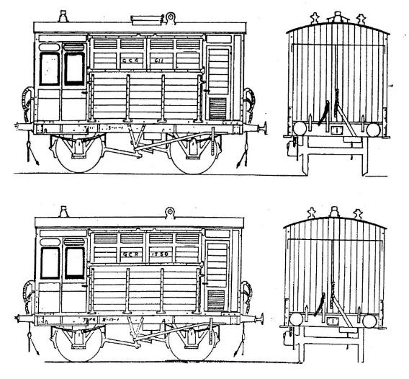**Historical notes**

**G.C.R. diagram 1X4**

The Gloucester Railway Carriage and Wagon Co. built 45 in 1898, and they were numbered in the passenger stock series, nos. 1549-1593; a good photograph of one of these vans may be found in George Dow's "Great Central" vol.2. These were renumbered in early L.N.E.R. days into the box series, nos. 954-998. The lot built at Gorton between 1897 and 1902 were first numbered in the passenger stock series, with nos. 599, 604, 611, 614, 616, 618, 622, 624, 626, 627, 629, and possibly 628 also; in early L.N.E.R. days they were all renumbered into the box series; nos. 903, 908, 915, 917, 918, 920, 922, 926, 928, 930, 931, 933. (Later building to this design - post-1902 - had slightly different panelling on the sides).

G.C.R example of a Gorton-built vehicle with the extra roof ventilator, in pre 1902 lettering.

**Livery**: from new to 1910 - middle to dark brown including solebars, roof white (becoming grey), below solebars black, wheel centres brown, tyres white, letters and numerals gold about 4 1/2" high, tare and load gold, lining was as shown in the illustration on p278 of vol.2 of Dow’s book.

From 1910 to Grouping; natural varnished teak (probably plain teak-brown paint) with lettering as above.

L.N.E.R. period: teak brown with white letters.

**Cheshire Lines Committee diagram 79**

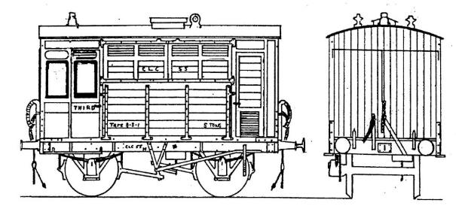Built at Gorton to the standard G.C.R. design, they were built in three lots - three in 1900 (numbered 149, 152, 154); six in 1901 (nos. 54, 55, 56, 1488, 153, 157); and two in 1902 (nos. 57, 156). Tare weight was in the region of 8-10-0, they were fitted with vacuum brakes and had Westinghouse through pipes (later removed from nos. 54, 55, 154).

**Livery**: pre-1923 the body sides and ends were varnished teak, fully lined-out (as on the G.C.R. examples) in yellow. Wheel centres were brown (originally varnished wood on Mansell wheels). White wheel tyres and roofs when new. Solebars, headstocks, W-irons, springs and buffer-guides bronzed green. Spring hangers, couplings and brake-gear black. Interiors: light green walls, white ceilings and black floors.

By 1923 the stock was all painted "oak brown", rather than varnished, unlined, and with black running gear. Withdrawals started in 1927-1932: there were six left in 1938 (nos.54-57, 153, 154); no.55 was withdrawn in March 1938 and no.54 in July 1939, and the remaining four lasted until September 1950 (but were probably never repainted by B.R.).

**References**

1. Dow G. "Great Central”, three volumes (lan Allan 1959-1965)

2. "Forward" (Great Central Railway journal) nos.76 and77. (1990). Article on CLC horse boxes.

3. Historical Model Railway Society photographs - can be purchased by members.

The talented modeller Steve Banks wrote a very useful article on this kit in the February 2004 issue of Model Rail and details can be found on his website <http://www.steve-banks.org/>

**Acknowledgements**

We would like to thank G.C.R.S. member John Quick, H.M.R.S. member Bob Miller, and Merseyside M.R.S, member David Goodwin, for help with the historical information.

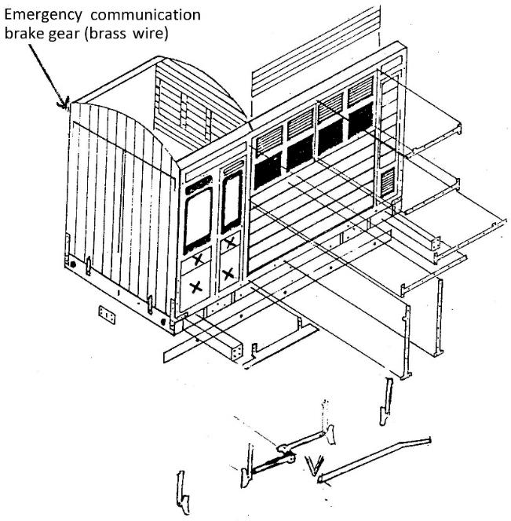**Instructions**

Carefully remove the main body panel from the fret and punch in the bolt-head detail from the rear. Solder thin brass wire into the half-etched grooves of the two panels (marked "X" in the exploded diagram) beneath the two windows on each side.

Fold up the sides and roof support (all bends have the crease line on the inside of the bend **except** for the keeper plates on the W-irons). Prepare the van ends: punch in the bolt-head detail, fold over the headstock ends, tack assemble the ends to the van sides ensuring squareness, slide in the partition for the groom’s compartment and tack.

Fit the planking detail to the back of openings below the top louvres - it is advisable to glue this part into position to avoid an excess of solder getting onto the plank detail. Fold down from the floor the pivot for the rocking W-iron, fit the solebars to the slots, fit the solebar stiffening strips to the backs and solder through the holes. Fit the solebar/headstock plates, fit the door T-handles to the doors, fold up and fit the T-section strapping to the headstocks and lower van sides, fit all the hinges (see drawings for positions).

Fold up and fit the W-irons and wheel bearings (it may be necessary to enlarge slightly the holes for the bearings in the W-irons). With the wheels in position, fit the brake hangers, push-rods, V-hangers, brake cylinder and handbrake levers; fold up and fit to the solebars the brake-lever guides. Fit the axle-boxes and springs, fold up and fit the footboards (the longer one as shown on the diagram, the shorter one on the opposite side by the brake-lever.

Fit the draw-hook plates, lamp irons, buffers and brake pipes. (For those who intend spraying their model, this would be a good stage to do so). Fit the glazing and the roof, roof ventilators and lamp top. Note that the Gorton-built vehicles had an extra clerestory-type ventilator fitted, represented by a whitemetal casting.

|  |  |  |
| --- | --- | --- |
| **Whitemetal castings** |  | **Required to complete** |
| Long buffers | 4 | Wheels (3’ 7” Mansell), couplings |
| Vacuum brake standpipe | 2 | 15 thou plasticard for roof (optional alternative) |
| Vacuum cylinder | 1 | Wire, paint and transfers |
| Vacuum cylinder lever | 1 |  |
| Westinghouse air brake standpipe | 2 |  |
| Roof light | 1 |  |
| Torpedo vents | 2 |  |
| Oil pot lamp top | 1 |  |
| J-hanger axlebox spring | 4 |  |
| Oil axlebox | 4 |  |

